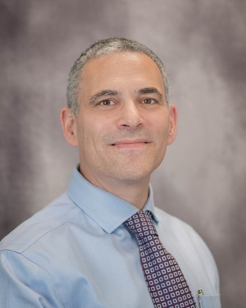

**Michael Reinhorn, MD, MBA, FACS**

Dr. Michael (Micki) Reinhorn is a board-certified surgeon specializing ambulatory hernia and pilonidal surgery. He is the Co-Founder of Boston Hernia based in Wellesley, Massachusetts, and pioneered a new minimally invasive hernia repair surgery that allows a faster recovery and less reliance on opioids.

He is an associate clinical professor at Tufts University and a consultant for the American Board of Surgery. He is also the Chairperson of the Opioid Reduction Task Force for the Abdominal Core Health Quality Collaborative, which is working to reduce the impact that post-op prescribing has on the epidemic. He has performed over 4,000 abdominal wall hernia repairs, over 700 gallbladder surgeries, more than 130 successful Cleft Lift operations for pilonidal in 21 years of practice and over 400 hernia operations a year.

He obtained his Doctor of Medicine from Boston University, where he also completed General Surgery Residency. In addition, he has a Master of Business Administration from the Heller School for Social Policy and Management at Brandeis University and a Bachelor of Science in Biological Engineering from Cornell University.

Dr. Reinhorn and has lectured nationally about groin injuries, defining value in hernia care, patient reported outcomes, opioid reduction strategies and inguinal hernia surgery and anatomy. He has authored and co-authored peer reviewed publications and book chapters on inguinal hernia surgery.

When not working, he enjoys time with his wife and three children, including hiking in the White Mountains, swimming, biking, traveling and cooking.